Sales Dashboard Project Report

Developed by
Kavya S
Project Title
Interactive Sales Analytics Dashboard using React.js and Rechart
Project Overview
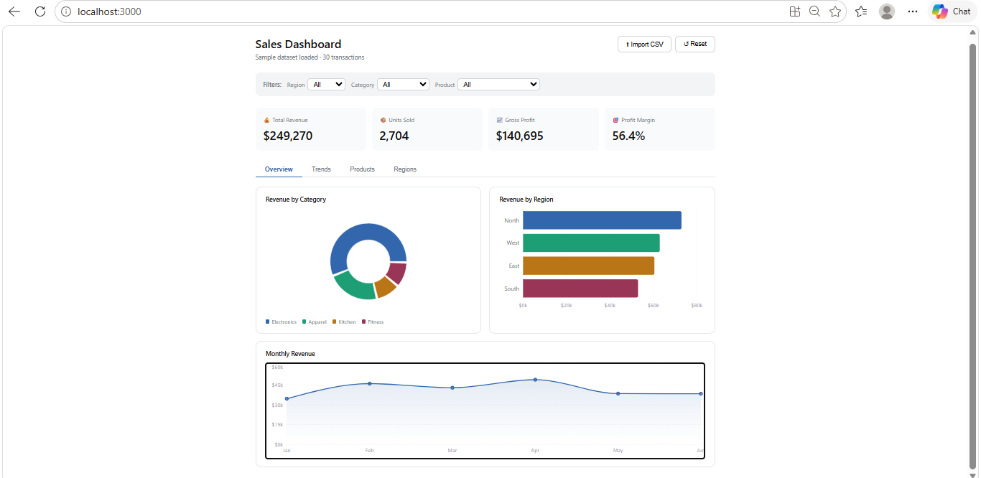

The Sales Dashboard is a web-based analytics application developed using React.js and the Recharts visualization library. The application provides interactive visualizations and business insights by analyzing sales data. Users can monitor revenue, profit, product performance, and regional sales trends through a modern and responsive dashboard interface.
The dashboard supports dynamic filtering and CSV file import, allowing users to analyze custom datasets and generate real-time visual reports.
Objectives
- Visualize sales performance through charts and graphs.
- Monitor key business metrics.
- Analyze product and regional performance.
- Enable data-driven decision making.
- Support custom data uploads using CSV files.
Technologies Used
- React.js
- JavaScript (ES6)
- Recharts
- HTML5
- CSS3
- npm
- Git & GitHub
Dashboard Features
KPI Cards
The dashboard displays important business metrics:
- Total Revenue
- Units Sold
- Gross Profit
- Profit Margin
Interactive Filters
Users can filter sales data by:
- Region
- Category
- Product
Revenue by Category
A pie chart showing the revenue contribution of different product categories.
Revenue by Region
A horizontal bar chart comparing revenue across different sales regions.
Monthly Revenue Trend
A line chart displaying monthly revenue growth and performance over time.
Product Analytics
Provides detailed product-wise sales and revenue information.
Region Analytics
Shows region-wise performance and revenue contribution.
CSV Import Functionality
Users can upload CSV files containing sales records and instantly visualize the imported data.
Benefits
- Easy interpretation of sales data.
- Better business decision making.
- Interactive and user-friendly interface.
- Real-time data filtering and analysis.
- Flexible data import functionality.
Future Enhancements
- Dark Mode
- Database Integration
- Real-Time API Connectivity
- PDF/Excel Report Export
- Predictive Analytics and Forecasting
- User Authentication
Conclusion
The Sales Dashboard successfully provides an interactive platform for analyzing sales performance. By combining React.js and Recharts, the project delivers a responsive and visually appealing dashboard capable of handling business analytics efficiently.

